HANOI UNIVERSITY
FACULTY OF INFORMATION TECHNOLOGY
----🙥∙🙧🕮🙥∙🙧----



WonTon POS - Order Management, Payment & Revenue Analytics System for Wonton Noodle Shop
Project Thesis

COURSE NAME: Software Requirements Analysis (61FIT3REQ)
Spring - 2026

- Nguyen Thi Hai My | 2301040126
- Nguyen Dat Vinh | 2301040198
- Vuong Gia Ly | 2301040113
- Nguyen Minh Duc | 2301040048
- Dang Khanh Huyen | 2301040088
- Le Thanh Dat  - Nguyen Dinh Chien  - Nguyen Thien Hieu | 2301040036  2301040025  2301040071
Team Guide: Hoang Ngoc Duy
Task Evaluation

Member | Role | Task
Nguyen Thi Hai My | Project Manager | - BRD Ver 0  - Elicitation Notes: Interview  - BRD Ver 2: Appendix C (ERD)  - Prototype UI: 2 interfaces UI  - Thesis: III. Client: Overview, Problem Statement and Requirements
Nguyen Dat Vinh | System Analyst | - BRD Ver 0  - Elicitation Notes: Questionaires  - BRD Ver 2: Appendix C (ERD)  - Prototype UI: 10 interface UI  - Thesis: I. Introduction
Vuong Gia Ly | Data Analyst | - BRD Ver 0  - BRD Ver 2: Business Cases  - Prototype UI: 2 interface UI  - Thesis: II. Literature Review
Nguyen Minh Duc | Business Process Analyst | - BRD Ver 0  - Elicitation Notes: Preparation  - BRD Ver 2: Appendix C (Data Flow DFD)  - Prototype UI: 2 interface UI  - Thesis: IV. Application of Elicitation Techniques
Dang Khanh Huyen | User Experience Analyst | - BRD Ver 0  - Elicitation Notes: Observation  - BRD Ver 2: Appendix C (Class Diagram)  - Prototype UI: 2 interface UI  - Thesis: VI. Requirement Management
Le Thanh Dat | Requirement Analyst | - BRD Ver 0  - BRD Ver 2: Appendix C (Class Diagram)  - Prototype UI: 2 interfaces UI  - Thesis: I. Introduction
Nguyen Dinh Chien | System Analyst | - BRD Ver 0  - Elicitation Notes: Meeting  - BRD Ver 2: Appendix C (Data Flow DFD)  - Prototype UI: 2 interfaces UI  - Thesis: VIII. Revision of Project
Nguyen Thien Hieu | Data Analyst | - BRD Ver 0  - Elicitation Notes: Observation  - BRD Ver 2: Appendix C (Class Diagram)  - Prototype UI: 2 interfaces UI  - Thesis: VII. Prototype

Project Thesis

I. Introduction
In recent years, the food service industry has experienced rapid digital transformation as businesses increasingly adopt technology to enhance operational efficiency and improve customer experience. Small and medium-sized restaurants, in particular, are under growing pressure to streamline their workflows, reduce human errors, and remain competitive in a market dominated by digital ordering platforms. As customer expectations continue to evolve toward faster service, convenience, and real-time interaction, traditional manual processes are becoming inadequate and inefficient for daily restaurant operations. This rapid shift has created a highly competitive environment, where businesses must modernize their operations to meet increasing demands.
Despite the availability of third-party food delivery platforms such as GrabFood and ShopeeFood, many small restaurant businesses still face significant operational and financial challenges. A major challenge lies in their reliance on manual processes for order handling, communication, and revenue tracking. In the case of the wonton noodle shop client, orders are recorded manually on paper or through verbal communication between staff members, which often leads to order inaccuracies, delays, and miscommunication between the cashier and kitchen. Additionally, the absence of a centralized system results in a lack of reliable business data, making it difficult for the owner to analyze sales performance, identify peak hours, or make informed business decisions. Furthermore, dependence on third-party platforms introduces high commission fees, reducing profit margins and limiting the restaurant’s control over its own customer experience and operations. Collectively, these inefficiencies reduce service quality, impact customer satisfaction, and hinder sustainable business growth.
To address these challenges, the client seeks to develop an independent and integrated Point of Sale (POS) system tailored specifically to the operational needs of a wonton noodle restaurant. The proposed solution, known as the WonTon POS – Order Management, Payment & Revenue Analytics System, aims to digitize and automate the entire restaurant workflow. This system is designed to reduce manual errors, improve communication between front-of-house and back-of-house staff, and provide real-time insights into business performance. By establishing an internal ordering channel, the restaurant can reduce dependency on third-party platforms and gain greater control over customer interactions and revenue streams.
This thesis presents the design and development of the WonTon POS system, which consists of two primary components: a Client Web Application and an Admin Web Application. From the customer’s perspective, the system enables users to browse the menu, place orders online, select service types such as dine in, takeaway, or pickup, and complete payments through various methods. Customers can also track their order status in real time and access their order history. In addition, the system allows customers to make table reservations in advance, helping them secure seating and reduce waiting time during peak hours. These features are intended to enhance convenience, improve service efficiency, and increase overall customer satisfaction.
From the administrative perspective, the system provides a comprehensive set of tools to support restaurant management and operations. Staff members can efficiently manage orders, process payments, and coordinate with the kitchen through a digital workflow. Managers are equipped with functionalities to manage menu items, control staff accounts with multiple roles, and oversee table arrangements for dine-in services. In addition, the system offers a revenue analytics dashboard that allows the owner to monitor key business metrics, such as total revenue, best-selling items, and peak operating hours. These insights enable data-driven decision-making and support long-term business growth. These integrated functionalities not only streamline daily operations but also enhance coordination among staff and improve overall service efficiency.
Overall, this project represents more than just a technological solution; it embodies a strategic approach to digital transformation in the restaurant industry. By eliminating inefficient manual processes and reducing dependency on third-party platforms, the WonTon POS system enhances operational autonomy, improves profitability, and enables the restaurant to deliver a more consistent and high-quality customer experience.

II. Literature Review
The rapid digital transformation of the food and beverage industry, particularly within small and medium sized enterprises, has created a dynamic and evolving environment in which technology plays a central role in enhancing operational efficiency and customer experience. In recent years, Point of Sale systems have emerged as one of the most critical technological solutions adopted by restaurants to streamline operations and support business growth. This literature review aims to critically synthesize findings from a range of academic studies, industry reports, and professional resources in order to establish a comprehensive understanding of the key factors influencing the adoption, implementation, and effectiveness of POS systems within restaurant environments.
The review spans multiple interconnected domains that are essential to the successful design and deployment of POS systems. Firstly, it examines the current state of technology adoption within the food and beverage sector, with particular attention to small and medium sized businesses. According to recent industry analysis, while POS systems are widely adopted in Vietnam, many establishments still rely on basic functionalities and lack advanced integrations such as kitchen display systems and analytics tools (B Company, 2025). This indicates that although digital transformation is underway, there remains a significant gap between the capabilities of existing systems and the increasing demands of modern restaurant operations. Such limitations can restrict business growth, reduce operational efficiency, and prevent restaurants from fully leveraging the benefits of digital technologies. This highlights the importance of developing more integrated and scalable solutions that can address these shortcomings.
In addition to adoption trends, the literature also emphasizes the operational impact of POS systems on restaurant performance. Empirical studies demonstrate that POS systems contribute significantly to improving efficiency by automating order processing, reducing manual errors, and enabling better inventory management (IJIRT, 2024; IJCRT, 2020). These improvements are particularly important in fast paced restaurant environments where speed and accuracy are critical to customer satisfaction. Furthermore, the integration of digital systems enhances communication between front of house and kitchen staff, thereby reducing delays and minimizing miscommunication. However, despite these benefits, several challenges remain. Implementation costs, system complexity, and the need for staff training are frequently cited as barriers to adoption, especially for smaller businesses with limited financial and human resources (IJIRT, 2024). This suggests that successful system design must balance advanced functionality with usability and cost effectiveness in order to ensure practical applicability.
Another critical aspect discussed in the literature is the need for customization and adaptability in POS system design. Restaurants often have unique operational requirements depending on their cuisine, service model, and customer base. For instance, restaurants specializing in Asian cuisine may require flexible menu configurations, support for multiple languages, and the ability to manage complex dish variations and toppings (GoSnappy, 2025). This highlights the importance of designing systems that are not only functional but also adaptable to diverse business contexts. A rigid solution may fail to meet specific operational needs, thereby limiting its effectiveness. Therefore, customization emerges as a key design principle that enables systems to better align with real world restaurant operations.
The role of data analytics in enhancing business performance is another major theme explored in the literature. Modern POS systems generate large volumes of transactional data that can be analyzed to uncover valuable insights into sales trends, customer behavior, and operational patterns (NRSPlus, 2024; Shopify, 2025). These insights enable restaurant owners to make informed decisions regarding menu optimization, pricing strategies, and resource allocation. For example, identifying best selling items and peak operating hours can help improve inventory planning and staff scheduling. Moreover, the integration of advanced technologies such as artificial intelligence and business intelligence tools allows for real time reporting and predictive analytics, further enhancing decision making capabilities (Mona Media, 2025; GoFrugal, 2025). This demonstrates that POS systems are no longer merely transactional tools, but have evolved into strategic platforms that enable data driven decision making and support long term business growth.
From a behavioral perspective, the adoption of POS systems is influenced by several psychological and technological factors. Research based on the UTAUT2 model indicates that perceived usefulness, ease of use, and perceived risk significantly affect the intention of restaurant owners to adopt new technologies (AaltoDoc, 2020). This implies that system designers must prioritize user friendly interfaces and reliable performance in order to build trust and encourage adoption. If a system is perceived as complex or risky, businesses may be reluctant to invest in it despite its potential benefits. Therefore, usability and reliability are critical considerations in the design and implementation of POS systems.
Furthermore, clearly defined functional requirements play a vital role in ensuring the effectiveness of POS systems. Industry guidelines emphasize the importance of including core features such as order management, payment processing, inventory tracking, and reporting capabilities (LimeTray, 2025). These features form the foundation of a comprehensive system that supports both daily operations and strategic decision making. The absence of any of these functionalities can significantly reduce the overall value of the system. Therefore, requirement definition must be thorough and aligned with business needs in order to ensure system success.
Collectively, these thematic areas provide a holistic understanding of the challenges and opportunities associated with POS system development in the restaurant industry. By integrating insights related to technology adoption, operational efficiency, customization, data analytics, user behavior, and functional requirements, this review establishes a strong theoretical foundation for the proposed WonTon POS system. The synthesis of these findings highlights the necessity of developing an integrated, user friendly, and data driven solution that can effectively address real world business challenges.
Building upon this theoretical foundation, the project applies several Business Analysis methodologies and techniques to ensure effective requirement elicitation and system design. Requirements elicitation is a critical process that involves gathering, analyzing, and validating stakeholder needs in order to define system requirements accurately. This process is essential because it directly influences the success of the system by ensuring that the final solution aligns with business objectives and user expectations.
In this project, multiple elicitation techniques are employed to capture comprehensive and reliable information. The interview technique is used to gather detailed insights from key stakeholders such as the restaurant owner and staff. This technique is chosen because it allows direct interaction and enables the analyst to explore specific issues in depth. Through structured and semi structured interviews, stakeholders can share their experiences, challenges, and expectations, providing valuable qualitative data that cannot be obtained through other methods (Pegotec, 2025). This approach is particularly useful for understanding complex workflows and identifying hidden problems within the current system.
The observation technique is also applied to examine real world operations within the restaurant environment. This technique is chosen because it provides direct evidence of actual practices, allowing the analyst to identify inefficiencies and communication gaps that may not be explicitly mentioned by stakeholders. By observing how orders are taken, processed, and delivered, the analyst can gain a deeper understanding of operational challenges and validate information obtained through interviews. This combination of observation and interview enhances the accuracy and reliability of the collected data.
In addition to qualitative methods, questionnaires are used to collect feedback from customers. This technique is selected because it enables the collection of data from a larger sample size in a relatively efficient manner. Questionnaires provide quantitative insights into customer preferences, satisfaction levels, and expectations, which are essential for designing user centered features. The use of structured questions allows for easy analysis and comparison of responses, supporting data driven decision making.
Furthermore, stakeholder meetings are conducted to validate requirements and ensure alignment among all parties involved. These meetings serve as a platform for discussion, clarification, and consensus building. This technique is chosen because it helps resolve ambiguities, confirm requirements, and establish a shared understanding of system scope and priorities. Through collaborative discussions, stakeholders can provide feedback, suggest improvements, and agree on final decisions, thereby reducing the risk of misunderstandings and ensuring project success.
In addition to elicitation techniques, several supporting tools are utilized to enhance analysis and communication. Tools such as Use Case modelling, process flow representation, and stakeholder analysis frameworks are applied to visualize system interactions and structure requirements effectively (GetSoftwareService, 2024). These tools are chosen because they improve clarity, facilitate communication, and support collaboration among stakeholders. By representing complex processes in a visual format, these tools help ensure that all stakeholders can easily understand system functionality and requirements.
In conclusion, this literature review provides a comprehensive and in depth understanding of the key factors influencing the development and adoption of POS systems in the restaurant industry. By critically analyzing technology trends, operational benefits, customization requirements, data analytics capabilities, behavioral factors, and Business Analysis methodologies, it highlights the multifaceted nature of digital transformation in this domain. The insights derived from this review form a solid foundation for the subsequent stages of the project, particularly in defining system requirements and designing a solution that effectively addresses both business needs and user expectations.

III. Client

Overview
The client for this project is a Wonton Noodle Shop, a small to medium-sized restaurant that operates in the competitive food service industry. Currently, the shop processes an average of 150-300 orders per day and employs 4-8 staff members. While the business has adapted to the presence of third-party food delivery platforms such as GrabFood and ShopeeFood, the restaurant does not yet have an internal system for managing orders, payments, and business analytics. As a result, all operational processes are handled manually. For instance, orders are recorded on paper, and communication between the cashier and the kitchen is done verbally, creating inefficiencies and increasing the risk of errors.
In terms of their current information system, the Wonton Noodle Shop does not employ any Point of Sale (POS) or order management system. Their reliance on manual processes significantly limits their ability to track sales, analyze customer behavior, and manage day-to-day operations effectively. This has led to inefficiencies in handling orders, inaccurate revenue tracking, and difficulty in making informed business decisions.

Problem Statement
The Wonton Noodle Shop is struggling with significant inefficiencies and errors due to its manual operational processes. Currently, all orders are taken manually, either recorded on paper or communicated verbally between the front-of-house (FOH) and back-of-house (BOH) staff. This leads to multiple issues: order inaccuracies are common, as handwritten notes or verbal communication can be misinterpreted, resulting in wrong items or quantities being prepared. These mistakes contribute to delays in order fulfillment, as the kitchen may not receive orders on time, especially during busy periods, causing longer wait times for customers. Communication breakdowns between FOH and BOH staff also result in confusion about the status of orders, leading to missed or incomplete orders. Furthermore, there is no centralized system to track sales performance, inventory, or customer preferences. This lack of real-time business data prevents the owner from making informed decisions about menu optimization, inventory management, or staffing. These inefficiencies not only reduce service speed but also negatively impact customer satisfaction, profitability, and the shop's ability to grow.
To resolve these problems, the restaurant requires an integrated Point of Sale (POS) system that automates order management, payment processing, and generates real-time business analytics. This system would eliminate manual errors, improve communication between staff, and provide actionable insights into sales, customer behavior, and operational performance, ultimately improving the shop's overall efficiency, customer service, and profitability.

Vision and Scope
Product Vision
The vision of Wonton POS is to provide a focused digital operating system for a small wonton noodle shop, replacing paper-based ordering and verbal coordination with a controlled order, payment, kitchen, and reporting workflow. For customers, the product should make ordering, payment, pickup timing, and order tracking clear and convenient. For staff, it should reduce miscommunication between FOH and BOH, provide a reliable Kitchen Display System (KDS), and give managers timely visibility into sales, exceptions, and end-of-day reconciliation.
The business opportunity is not to build a broad restaurant super-app, but to solve the shop's current operational bottleneck with a system that is narrow enough to finish and realistic enough to be valuable. The proposed product supports the restaurant's core service models: Dine-in, Takeaway, and scheduled Pickup. It also supports the two main user surfaces required by the project: the Client WebApp for customers and the Admin WebApp for manager, cashier, service, and kitchen staff.
Business Objectives and Success Metrics
Objective / metric | Target for Wonton POS | Rationale
Order accuracy | Reduce order-entry and kitchen-communication errors compared with the current handwritten/verbal process. | The main business pain point is wrong or missing items caused by manual communication.
Service speed | Keep customer-facing actions such as browsing, checkout, and tracking simple enough for peak-hour use. | The shop handles high lunch/dinner traffic and cannot afford slow operational screens.
Payment control | Prevent Takeaway and Pickup orders from entering kitchen preparation until valid payment is confirmed. | This protects the shop from abandoned prepaid orders and unclear payment responsibility.
Operational visibility | Give managers a daily view of orders, revenue, exceptions, 86d items, refunds, and shift close/reconciliation. | The owner currently lacks centralized information for business decisions.
Customer satisfaction | Provide order tracking, notification, pickup clarity, and post-order rating to reduce uncertainty and collect feedback. | Customers need confidence that their order is correct, paid, prepared, and ready for handoff.
Vision Statement
For customers and restaurant staff who need a faster and more reliable way to place, prepare, pay for, and monitor wonton noodle orders, Wonton POS is a web-based POS and order-management system that integrates customer ordering, cashier settlement, kitchen preparation, table/pickup operations, and management reporting. Unlike the current paper-and-verbal workflow, the system provides a single traceable source of order, payment, and operational status across Client WebApp and Admin WebApp.
Project Scope
Scope element | Current release | Future / excluded release
Major features | Online ordering, guest checkout, registered account flow, menu/cart/checkout, payment status, order tracking, KDS, table management, active orders, promotion, refund/exception handling, 86d availability, shift close, and reporting. | Delivery integration, loyalty points, supplier procurement, native mobile app, payroll, and full accounting ledger.
Initial release boundary | Curated UC-01..UC-26 lane shown in the thesis/BRD/SRS, with supporting business rules and exception flows from the full-system inventory. | The full UC-01..UC-74 inventory remains the master scope reference but is not pasted wholesale into the requirement narrative.
Limitations and exclusions | Prototype and documentation-first requirement package for project review. | Production deployment, real bank settlement integration beyond documented assumptions, and operational go-live commitments.
Stakeholder priorities | Feature correctness, quality, schedule, cost discipline, and staff usability. | Gold-plated features that do not reduce the core operational pain points.
Business Risks
Business risk | Cause | Control in Wonton POS scope
Expectation gap | Sponsor or staff may expect a full restaurant platform rather than a focused POS baseline. | Use the Vision and Scope boundary, stakeholder reviews, and prototype walkthroughs to confirm what is included and excluded.
User acceptance risk | Staff may prefer familiar paper/verbal routines during rush hours. | Keep Admin workflows role-based, touch-friendly, and focused on fast order, KDS, payment, and handoff actions.
Timing risk | The project schedule may not allow every desirable extension. | Prioritize Must/Should requirements and keep Could/Wont-have-now items in the future-release boundary.
Business-rule misunderstanding | Payment, refund, pickup no-show, 86d, and reconciliation rules are operationally sensitive. | Maintain explicit business rules and map them to UC alternate/exception flows and prototype evidence.

Requirements
Functional Requirements
The WonTon POS - Order Management, Payment & Revenue Analytics System for the Wonton Noodle Shop must provide a comprehensive solution to digitize and optimize the restaurant's operations. The system should streamline the entire order flow, from customer order placement to payment processing and revenue tracking. A user-friendly homepage must allow customers to easily browse the menu, select items, and proceed to the checkout process. Customers should have the option to place orders as either registered users or guest customers.
The platform must include a detailed product catalog, listing menu items with names, descriptions, prices, availability, and high-quality images. Customers should be able to filter products based on service type (Dine-in, Takeaway, Pickup), price range, or special preferences. A powerful search function must enable customers to find items by name, category, or keywords. The system should also offer an intuitive shopping cart feature, where customers can add, modify, or remove items. For registered users, cart contents must persist across sessions.
The checkout process must be secure and simple, supporting multiple payment methods, including credit cards, QR payments, and bank transfers. Once an order is placed, the system must send an email confirmation along with a digital receipt. For Dine-in orders, the payment can be completed later at the restaurant, while Takeaway and Pickup orders must require prepayment.
From an administrative perspective, the system must allow managers to add, edit, or remove menu items, update product prices, and manage item availability. It should also include tools to track inventory levels, process customer orders, and manage staff roles and accounts. Additionally, the platform must support revenue analytics, enabling managers to review sales data, top-selling items, peak-hour analytics, and export reports for decision-making. The system should allow customers to track their orders in real time, providing transparency and improving communication between the restaurant and its customers.
For customer feedback, the platform should include a review and rating system that allows customers to evaluate their orders. Moreover, the system must support operational features such as promoting and managing promotional codes, handling order exceptions, and processing refunds for eligible orders.
Non-Functional Requirements
The WonTon POS system must meet several non-functional requirements to ensure secure, efficient, and user-friendly operations. The system must protect sensitive customer data, including payment and personal information, using encryption (HTTPS/TLS) and secure password hashing. To protect financial transactions, the payment API interactions must be authenticated securely.
The platform must be highly available, with at least 99% uptime during the restaurant’s operating hours, ensuring smooth operations without interruptions. It should support a minimum of 200 concurrent users, enabling it to handle peak-hour traffic without performance degradation. The system must provide fast response times, with key user actions (such as placing orders or processing payments) completing within 2 seconds under normal operating conditions.
The user interface (UI) should be responsive and compatible with both desktop and mobile devices. It must be easy to navigate, intuitive, and modern, while also adhering to accessibility standards to support users with disabilities. The platform should provide real-time notifications to customers when order statuses change, and allow customers to track their orders via the web app. The system should also be scalable, ensuring that it can support future business growth, feature expansion, and ongoing improvements to meet evolving business needs.
Lastly, the platform must provide a robust and user-friendly administrative interface for managers and staff to efficiently manage the restaurant’s operations, including menu management, staff roles, and revenue analytics, all while maintaining ease of use and accessibility.
ID & Name: | UC-01: Place Online Order
Primary Actor: | Customer (Registered / Guest)
Description: | The customer accesses the Client WebApp (via account or Guest Checkout), browses the menu, selects items, chooses a service model, and enters the payment flow appropriate to that service model
Trigger: | The customer clicks the "Order Now" or "View Menu" button on the homepage
Pre-conditions: | The menu contains at least 1 item with status "Available"
Post-conditions: | The order is created successfully. If it is a Dine-in order, it may remain Unpaid; if it is a Takeaway or Pickup order, it proceeds only after valid payment is completed. A notification is sent to cashier/kitchen
Normal Flow: | 1.1. The customer selects a menu category (e.g., Wonton Noodles, Wontons, Beverages)  1.2. The system displays the list of items in the selected category (name, price, image, description)  1.3. The customer selects a desired item  1.4. The system displays item details, allowing selection of quantity, toppings, and special notes  1.5. The customer clicks "Add to Cart"  1.6. The system updates the cart, displaying the total number of items and total amount  1.7. The customer selects the service type (Dine-in / Takeaway / Pickup)  1.8. The customer clicks "Place Order"  1.9. The system creates the order and determines the payment rule based on the selected service model  1.10. If it is Dine-in, the system creates the order with Payment Status = Unpaid, displays the order code, and opens the order tracking screen  1.11. If it is Takeaway, the system routes the order to mandatory payment before kitchen release
Alternative Flows: | 2a. Add multiple items: After step 1.5, return to step 1.1 to add more items  2b. Edit cart: Before step 1.8, the customer can modify quantities or remove items from the cart  2c. Guest Checkout: Instead of logging in, the customer enters Name and Phone Number at checkout  2d. Pickup: At step 1.7, the customer selects "Pickup" → Continue to UC-03 for slot validation and mandatory prepayment
Exceptions: | E1: Item out of stock  E2: Empty cart when clicking "Place Order"
Priority: | Critical

ID & Name: | UC-13: Receive Kitchen Orders
Primary Actor: | Back-of-House Staff (BOH)
Description: | Kitchen staff views the list of new orders requiring preparation on the kitchen display, accepts orders, and begins cooking
Trigger: | A new order is created (from an online customer or in-store cashier). The system plays a notification sound
Pre-conditions: | 1. Kitchen staff is logged in with "Kitchen" privileges.  2. There is at least 1 new order
Post-conditions: | The order status changes from Pending Confirmation to Cooking. The customer is notified
Normal Flow: | 1.1. The system displays the kitchen screen with a list of new orders (Order ID, Item List, Notes, Service Type, Order Time)  1.2. Kitchen staff reviews the order details (items, quantities, toppings, special notes)  1.3. Kitchen staff clicks "Accept Order"  1.4. The system updates the order status to Cooking  1.5. The system sends a notification to the customer: "Order #X is now cooking"
Alternative Flows: | 2a. Reject order: At step 1.3, the kitchen clicks "Reject" -> Enters a reason (e.g., out of ingredients) -> The system notifies the cashier for handling  2b. Multiple orders simultaneously: The kitchen accepts orders in FIFO order (oldest order first)
Exceptions: | E1: Order cancelled before acceptance - At step 1.3, the system displays "Order has been cancelled by the customer" -> The order is removed from the list  E2: Connection lost - The system displays "Connection lost! The order list may not be updated. Please verify!"
Priority: | High

ID & Name: | UC-02: Online Payment
Primary Actor: | Customer (Registered / Guest)
Description: | After creating an order that requires prepayment, the customer selects an online payment method (MoMo, VNPay, ZaloPay, or QR bank transfer) to complete payment
Trigger: | The customer clicks "Pay Now" after cart confirmation or when the system requests payment before processing
Pre-conditions: | 1. The customer is logged in or has completed Guest Checkout with Name and Phone.  2. The cart contains at least 1 item.  3. The order has been created and belongs to a prepayment-required flow or the customer voluntarily chooses to prepay
Post-conditions: | Payment succeeds. The order changes to Paid. If it is Takeaway/Pickup, the order continues into operational processing
Normal Flow: | 1.1. The system displays the total order amount and available payment methods  1.2. The customer selects a payment method (e.g., MoMo)  1.3. The system redirects to the payment gateway page  1.4. The customer confirms payment on the MoMo/VNPay/ZaloPay application  1.5. The payment gateway returns the result to the system  1.6. The system displays "Payment successful!" and updates the order/payment status
Alternative Flows: | 2a. QR Bank Transfer:  2.1. Customer selects “QR Bank Transfer”  2.2. System displays a QR code with the payment amount  2.3. Customer scans the QR using a banking app  2.4. System confirms the payment after receiving the gateway callback  2b. Dine-in pay later:  2.1. If the order type is Dine-in, the customer may skip online payment  2.2. System creates the order with Unpaid status  2.3. Payment will be completed later at the counter
Exceptions: | Exception #1: Payment failed  1.1. Payment gateway returns error  1.2. System displays "Payment failed. Please try again!"  Exception #2: Payment timeout  2.1. If payment is not completed within 15 minutes  2.2. System cancels the order and displays "Order canceled due to payment timeout"
Priority: | Critical

ID & Name: | UC-05: Manage Menu
Primary Actor: | Manager
Description: | The manager adds, edits, and deletes menu items and categories, updates prices, images, and availability status
Trigger: | The manager clicks "Menu Management" on the Admin WebApp
Pre-conditions: | 1. The manager is logged in with "Manager" privileges
Post-conditions: | The menu is successfully updated; changes are immediately reflected on the Client WebApp
Normal Flow: | 1.1. The manager selects "Menu Management"  1.2. The system displays the menu list organized by categories (Wonton Noodles, Wontons, Beverages…)  1.3. The manager clicks "Add New Item"  1.4. The system displays a form: Item Name, Category, Price, Description, Image, Available Toppings  1.5. The manager enters the information, uploads an image, and clicks "Save"  1.6. The system validates the data, saves the new item, and displays "Item added successfully!"
Alternative Flows: | 2a. Edit item: At step 1.2, the manager clicks "Edit" on an item → The system displays the edit form with current data → The manager edits and clicks "Update" → Success  2b. Delete item: At step 1.2, clicks "Delete" → The system displays "Are you sure you want to delete this item?" → The manager confirms → Item is removed from the menu  2c. Mark as out of stock: At step 1.2, the manager toggles the item status to "Out of Stock" → The system updates; the Client WebApp shows "Out of Stock" for that item  2d. Manage categories: The manager clicks "Manage Categories" → Add / edit / delete categories
Exceptions: | E1: Duplicate item name — At step 1.5, the system displays "Item name already exists in this category!"  E2: Invalid price — At step 1.5, price ≤ 0 → Displays "Price must be greater than 0!"  E3: Image too large — At step 1.5, file > 5MB → Displays "Image exceeds 5MB. Please select a smaller file!"  E4: Deleting a category with items — At step 2d, the system displays "Cannot delete a category that still contains items!"
Priority: | High

IV. Application of Elicitation Techniques

1. Chosen Techniques
In the development of the WonTon POS system, a combination of elicitation techniques will be applied to gather requirements from stakeholders and ensure that the system is designed to meet the operational needs of the Wonton Noodle Shop. The techniques chosen are:
- Interviews: Structured and semi-structured interviews with key stakeholders such as the restaurant owner, managers, FOH staff, and BOH staff will be conducted. This will allow for in-depth understanding of user needs, pain points, and expectations.
- Observation: Observing the current manual workflows of the restaurant will help identify inefficiencies and gather real-world insights into how the system should be designed to improve operations.
- Questionnaires: Questionnaires will be distributed to customers to gain feedback on their expectations, preferences, and pain points regarding the ordering and payment process. This will help tailor the system to enhance user experience and meet customer demands.
- Workshops/Stakeholder Meetings: Meetings with key stakeholders will be held to validate the requirements and ensure alignment between all parties involved. These will help clarify ambiguities and confirm priorities for system features.

2. Deliverables of of such techniques, steps to perform

Interviews
Deliverables:
  - A detailed understanding of the current pain points and inefficiencies in the restaurant's operations (e.g., order handling, communication between staff, and payment processes).
  - Clear and prioritized system requirements based on the expectations of the restaurant management and staff.
  - Insights into the specific features needed, such as menu management, customer order tracking, and reporting.
Steps to Perform:
Plan:
- Identify key stakeholders to interview ( restaurant owner, FOH and BOH staff, managers).
- Prepare a list of interview questions that cover operational challenges, desired features, and business objectives. The questions should address both high-level system requirements and specific functional needs (What current processes are inefficient? What are the most critical features for the new system?).
Prepare:
- Schedule interviews with stakeholders and ensure they are aware of the purpose of the interview.
- Set up recording tools (with consent) and ensure interview guides are ready.
- Prepare an environment where the stakeholders can speak freely and share their insights.
Conduct:
- Conduct the interviews in a semi-structured manner, allowing for open discussion while still keeping the conversation focused on the set objectives.
- Ask follow-up questions based on responses to gain deeper insights into the challenges faced by staff and management.
Confirm:
- After the interviews, compile the key findings and share them with the interviewees for validation.
- Cross-check the insights with other elicitation methods (e.g., observations) to ensure consistency.
- Adjust and finalize the system requirements based on the feedback received.

Observation
Deliverables:
  - Workflow diagrams illustrating the current order management and operational processes in the restaurant.
  - Identification of inefficiencies and breakdowns in communication, such as delays between FOH and BOH or miscommunication during peak hours.
  - Insights into real-world problems that the system should address, such as order errors or slow payment processing.
Steps to Perform:
Plan:
- Identify the key workflows to observe (e.g., order-taking, communication between FOH and BOH, payment processing).
- Decide the best time to observe, ensuring it represents both typical and peak hours for the restaurant.
- Obtain permission from restaurant management to conduct the observations.
Prepare:
- Create an observation checklist or template to capture key data during the observation (e.g., time taken for each process, number of errors, communication breakdowns).
- Ensure all necessary equipment (e.g., notepads, recording devices) are ready.
Conduct:
- Observe the restaurant staff during their normal operations, taking note of any inefficiencies, delays, or breakdowns in communication.
- Focus on areas where errors commonly occur, such as order entry, payment processing, and kitchen coordination.
- Take detailed notes and, where possible, record video (with permission) to ensure accurate data collection.
Confirm:
- After observation, summarize the findings and share them with stakeholders to confirm that the issues identified are accurate and relevant.
- Use the observations to inform the design of the new system, ensuring that it addresses the inefficiencies and challenges observed.
- Validate that the identified issues are consistent with feedback gathered from other elicitation techniques, such as interviews.

Questionnaires
Deliverables:
Structured feedback on the current customer and staff experiences with the restaurant’s ordering and payment processes.
Insights into customer preferences for online ordering features, such as payment methods, order tracking, and service type (e.g., dine-in, takeaway, pickup).
Data-driven understanding of what features are considered most important for the new POS system (e.g., ease of use, speed, mobile compatibility).
Steps to Perform:
Plan:
- Define the objectives of the questionnaire: to gather feedback on current processes, assess customer preferences, and prioritize features.
- Develop a mix of closed (multiple-choice, Likert scale) and open-ended questions to capture both quantitative and qualitative data.
Prepare:
- Create the questionnaire, ensuring the questions are clear and concise. The questionnaire should address key areas such as customer satisfaction, ordering preferences, and potential pain points.
- Distribute the questionnaire to a representative sample of customers and restaurant staff, ensuring a broad range of responses.
Conduct:
- Distribute the questionnaire via email, in-store kiosks, or restaurant website. Allow enough time for participants to complete the survey.
- Collect responses and ensure the data is organized for analysis.
Confirm:
- Analyze the collected data, identifying trends, common responses, and areas where improvements are needed.
- Share the findings with stakeholders and adjust system requirements based on customer and staff feedback. Use this data to make informed decisions on the system's design.

Meetings
Deliverables:
  - A validated and agreed-upon set of system requirements, reflecting the collective input from all key stakeholders.
  - Finalized project scope, timeline, and priorities, ensuring that the project aligns with the business objectives and user needs.
Steps to Perform:
Plan:
- Schedule workshops with key stakeholders (e.g., restaurant owner, managers, FOH and BOH staff).
- Define the agenda for the workshop, focusing on confirming requirements, discussing use cases, and prioritizing features.
Prepare:
- Prepare materials for the workshop, such as process flow diagrams, use case templates, and requirement documents.
- Ensure that all stakeholders are briefed on the objectives of the workshop and are prepared to provide input.
Conduct:
- Facilitate the workshop, guiding discussions on requirements and confirming the agreed project scope.
- Address any ambiguities or conflicts between stakeholders, encouraging collaborative decision-making.
Confirm:
- Document the decisions made during the workshop and share them with stakeholders for confirmation.
- Finalize the system requirements based on the feedback and ensure that everyone agrees on the project's goals and priorities.

Prepare for Elicitation note
To ensure the success of the elicitation techniques, thorough preparation is essential. This phase ensures that all activities are aligned with project objectives and stakeholders are effectively engaged. The preparation involves the following key components:
Identify Stakeholders: Clearly identify the key stakeholders whose input will be crucial to the success of the project. These include individuals such as the restaurant owner, managers, staff (FOH and BOH), and customers. Ensuring the right people are involved at each stage will help gather relevant and valuable data.
Set Objectives: Clearly define what each elicitation technique is intended to achieve. For example, interviews aim to explore pain points and feature needs, while observation will highlight operational inefficiencies. The objectives for questionnaires might focus on customer expectations for the new system, and workshops will be aimed at aligning stakeholders on key features and project goals.
Create Documentation: Prepare the necessary materials to ensure smooth data collection. This includes:
  - Interview guides: Structured questions that allow you to extract detailed, qualitative information from stakeholders.
  - Observation checklists: Predefined points to guide the observer's focus during workflow observation, ensuring that no critical process is overlooked.
  - Questionnaires: Well-designed surveys with both closed and open-ended questions, ensuring you collect both quantitative and qualitative feedback.
  - Workshop agendas: A structured plan for meetings and workshops to ensure that all necessary topics are covered in the time available.
Coordinate Logistics: Organize and confirm all logistical aspects of the elicitation activities. This includes:
  - Scheduling: Ensure that stakeholders have agreed on dates and times for interviews, workshops, and observation sessions.
  - Tools: Set up tools such as Zoom for remote meetings, Google Docs for capturing live feedback, and recording devices (with consent) for interviews and workshops.
  - Participant Communication: Send clear invitations that explain the purpose of the elicitation session, the expected outcomes, and any preparation required from participants.
Example: Stakeholder Invitation Email
- Subject: "Stakeholder Workshop on POS System Requirements"
- Body: The email would include:
  - Topic: "Discussion on the features and requirements for the new POS system."
  - Date & Time: Clearly mention the scheduled time (e.g., 10:00 AM - 12:00 PM on 15/04/2026).
  - Link to Meeting: Provide the Zoom meeting link.
  - Goals: "To align on the main features of the POS system and ensure we are addressing operational challenges."
  - Expected Results: "We aim to have a validated set of system requirements and prioritize functionalities for development."
Risk Management: Identify potential risks that could impact the elicitation process and plan for them:
  - Requirement Changes Mid-Process: Requirements may evolve over time, so regular check-ins will ensure that any new or modified requirements are appropriately incorporated into the project.
  - Limited Availability of Participants: If key stakeholders are unavailable, offer alternative dates or send follow-up communications to gather their input after the session.
  - Technical Complexity: Some proposed features may require more time or resources than initially expected. Ensure that technical feasibility is evaluated early on with the development team.
  - User Adoption: If users are reluctant to adopt the system, use thorough user testing, continuous feedback loops, and iteration to improve the user experience.

Elicitation Technique Note
Each technique used in the elicitation process has its own specific best practices to ensure maximum effectiveness and accuracy of data collection:
- Interviews:
  - Best Practices: Maintain open communication with stakeholders. Ensure that you actively listen to their insights, concerns, and expectations. Use follow-up questions to delve deeper into specific issues and explore their needs in detail. Always ensure you document key points clearly, either through written notes or recordings.
  - Tip: Start with broad, open-ended questions to allow stakeholders to express their thoughts freely, then gradually narrow down to specific areas.
- Observation:
  - Best Practices: Be unobtrusive and avoid interrupting the staff during their normal workflow. Observe the entire process flow, noting any inefficiencies or bottlenecks that could benefit from automation or system improvement. The key is to gather real data about how current processes are carried out in the absence of a fully functional POS system.
  - Tip: Focus on key activities like order-taking, order transmission between FOH and BOH, payment processing, and customer service to uncover potential areas for system intervention.
- Questionnaires:
  - Best Practices: Design a balanced questionnaire that combines quantitative (e.g., Likert scale, multiple-choice) and qualitative (open-ended) questions. Ensure that the questions are clear, concise, and unbiased. Avoid leading questions to get authentic responses. Keep the survey short and engaging to ensure a high response rate.
  - Tip: Offer incentives or guarantees of confidentiality to encourage participants to be honest in their feedback.
- Meetings/Workshops:
  - Best Practices: Create a collaborative environment where all stakeholders feel comfortable sharing their thoughts and concerns. Facilitate discussions around system requirements, prioritize features, and resolve any conflicts between stakeholders. Use visual aids (e.g., diagrams, flowcharts) to support the discussions and ensure everyone is aligned.
  - Tip: Begin the session with clear goals and agendas, but remain flexible enough to explore any new issues that arise during the discussion.
Additional Tools for Effective Elicitation:
- Real-Time Documentation: Tools such as Google Docs or Google Drive can be used to capture real-time ideas, feedback, and requirements discussed during the session. This ensures all information is accessible to stakeholders after the session and prevents key points from being missed.
- Recording Sessions: If interviews or meetings are held virtually (e.g., via Zoom), recording the session (with consent) ensures that no important details are overlooked. This recording can then be reviewed for clarity and further analysis.
- Screenshots: During workshops or meetings, capturing key moments (e.g., discussions on diagrams or visual references) through screenshots can help preserve important insights and serve as useful references for later stages.
Confirming the Results:
After the elicitation activities, it’s crucial to ensure that all gathered information is validated:
- Documentation: Summarize all the findings from interviews, observations, questionnaires, and meetings in a clear document. Share this with all stakeholders for review and confirmation.
- Follow-up: Send out follow-up emails to stakeholders to validate the documented requirements and make any necessary adjustments before finalizing the system requirements.
- Incorporation into Project: Once the requirements have been validated, they will be formally incorporated into the Functional Requirements Document (FRD) and System Requirements Specification (SRS). These documents will provide the foundation for the development and implementation of the WonTon POS System.

V. Application of Modeling
1. Use case diagram for system
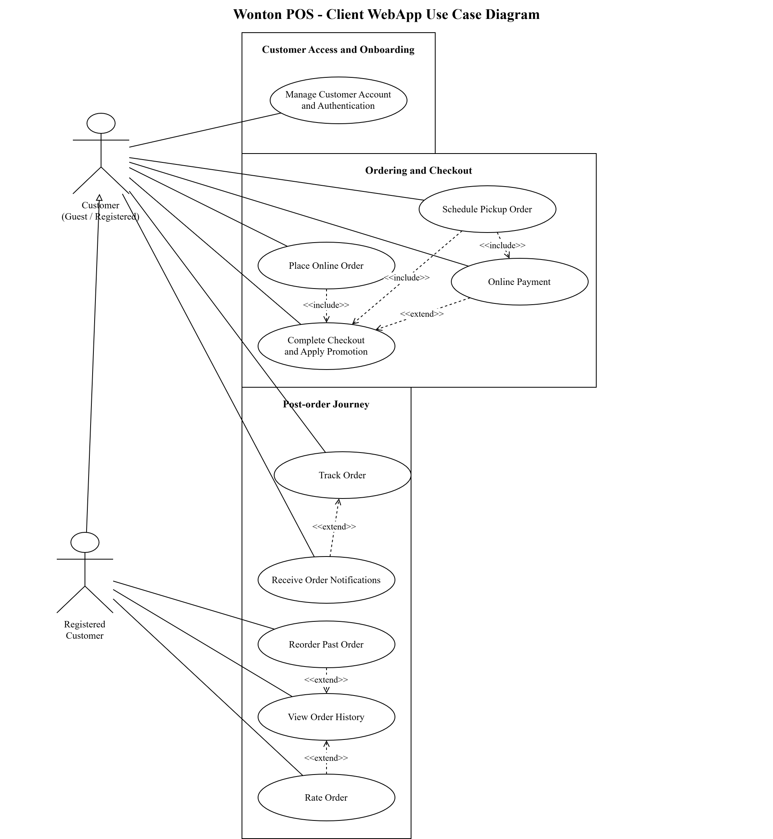
Figure 1a. Wonton POS - Client WebApp Use Case Diagram
The Use Case Diagram illustrates how customers interact with the WonTon POS system throughout the ordering process. It provides an overall view of system functionality and highlights how different features support users across multiple stages.
The diagram is organized into three main phases: Customer Access and Onboarding, Ordering and Checkout, and Post-order Journey. This structure helps clearly represent the user journey from accessing the system to completing and reviewing orders.
In the Customer Access and Onboarding phase, users interact with the system through the Manage Customer Account and Authentication use case. This includes activities such as login, registration, and account management, ensuring secure and personalized access.
In the Ordering and Checkout phase, customers can place orders through the Place Online Order use case. This process includes Complete Checkout and Apply Promotion, indicating that checkout is a required step. Additional functionalities such as Online Payment and Schedule Pickup Order are also integrated into this phase, allowing users to customize their ordering experience.
In the Post-order Journey, customers can track their orders using Track Order, while Receive Order Notifications provides real-time updates. The system also allows users to view past orders through View Order History, which is extended by Reorder Past Order and Rate Order, enabling customers to reorder items and provide feedback.
The diagram also shows relationships between use cases, such as the inclusion of Complete Checkout within the ordering process and extension relationships that represent optional features.
Overall, this diagram provides a clear and structured view of customer interactions, helping stakeholders understand how the system supports the full customer journey.

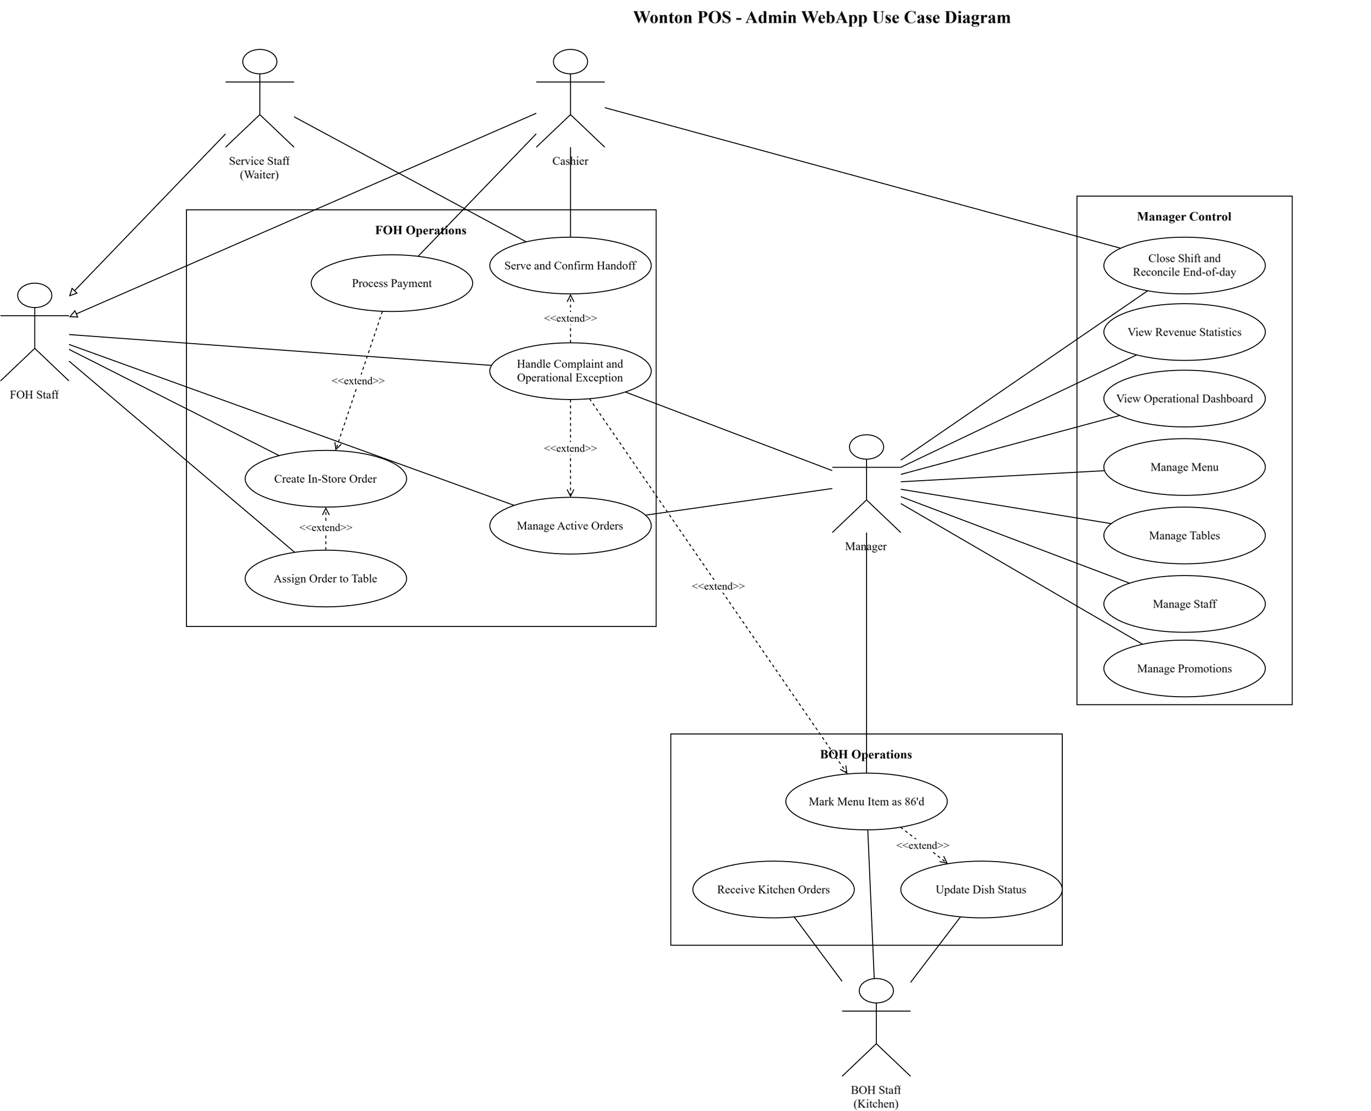
Figure 1b. Wonton POS - Admin WebApp Use Case Diagram
Figure 1b presents a part of the Use Case Diagram focusing on the interactions between FOH Staff, BOH Staff, and Manager within the WonTon POS system. This section highlights operational and management functionalities in the restaurant environment.
The FOH Staff actor is responsible for handling front-of-house activities. They interact with use cases such as Create In-store Order, Process Payment, Assign Order to Table, and Manage Active Orders. These use cases represent the workflow of handling customer orders, from order creation to service completion. In addition, actions such as Serve and Confirm Handoff and Handle Complaints and Operational Exceptions are connected through <<extend>> relationships, indicating that these activities occur only in specific situations.
The BOH Staff actor is associated with kitchen operations. They interact with use cases such as Receive Kitchen Orders and Update Dish Status, which support the preparation and progress tracking of food items. These interactions ensure smooth coordination between the kitchen and service staff.
The Manager actor is responsible for administrative functions. The diagram shows several use cases including Manage Menu, Manage Tables, Manage Staff, Manage Promotions, View Revenue Statistics, and View Operational Dashboard. These functionalities allow the manager to monitor system performance and control business operations effectively.
The relationships between use cases, including <<include>> and <<extend>>, help clarify system behavior by distinguishing between mandatory processes and optional actions. This improves the flexibility and realism of the system.
Overall, Figure 2 provides a clear view of internal operations, illustrating how different staff roles interact with the system to support both daily operations and management activities.

4. Detail of online tool to apply
During the development of the WonTon POS system, our team relied on draw.io (diagrams.net) as an essential tool for system modeling and diagram creation. As a free, browser-based platform, it provided easy access without requiring installation and allowed team members to work from different devices. This was especially helpful in a collaborative academic environment. The tool’s intuitive interface, drag-and-drop features, and diverse diagram elements enabled us to create clear and well-structured diagrams efficiently.
We used draw.io to construct key diagrams in the SRS, including Use Case Diagrams, Activity Diagrams (Swimlane), and Data Flow Diagrams (DFD). With its built-in UML components such as actors, use cases, and connectors, we were able to clearly represent the interactions between users and the system. The activity diagram features helped us illustrate the workflow of processes like ordering and payment, while the DFD tools allowed us to model how data flows between different components such as customers, staff, and the system.
In addition, draw.io supports exporting diagrams into multiple formats such as PNG and PDF, making it convenient for integrating visuals into reports and presentations. The tool also supports real-time collaboration, which helped team members contribute and update diagrams efficiently.
Overall, draw.io significantly improved the clarity, organization, and effectiveness of our system modeling process, making it an essential tool for developing and documenting the WonTon POS system.

2. Class diagram for system
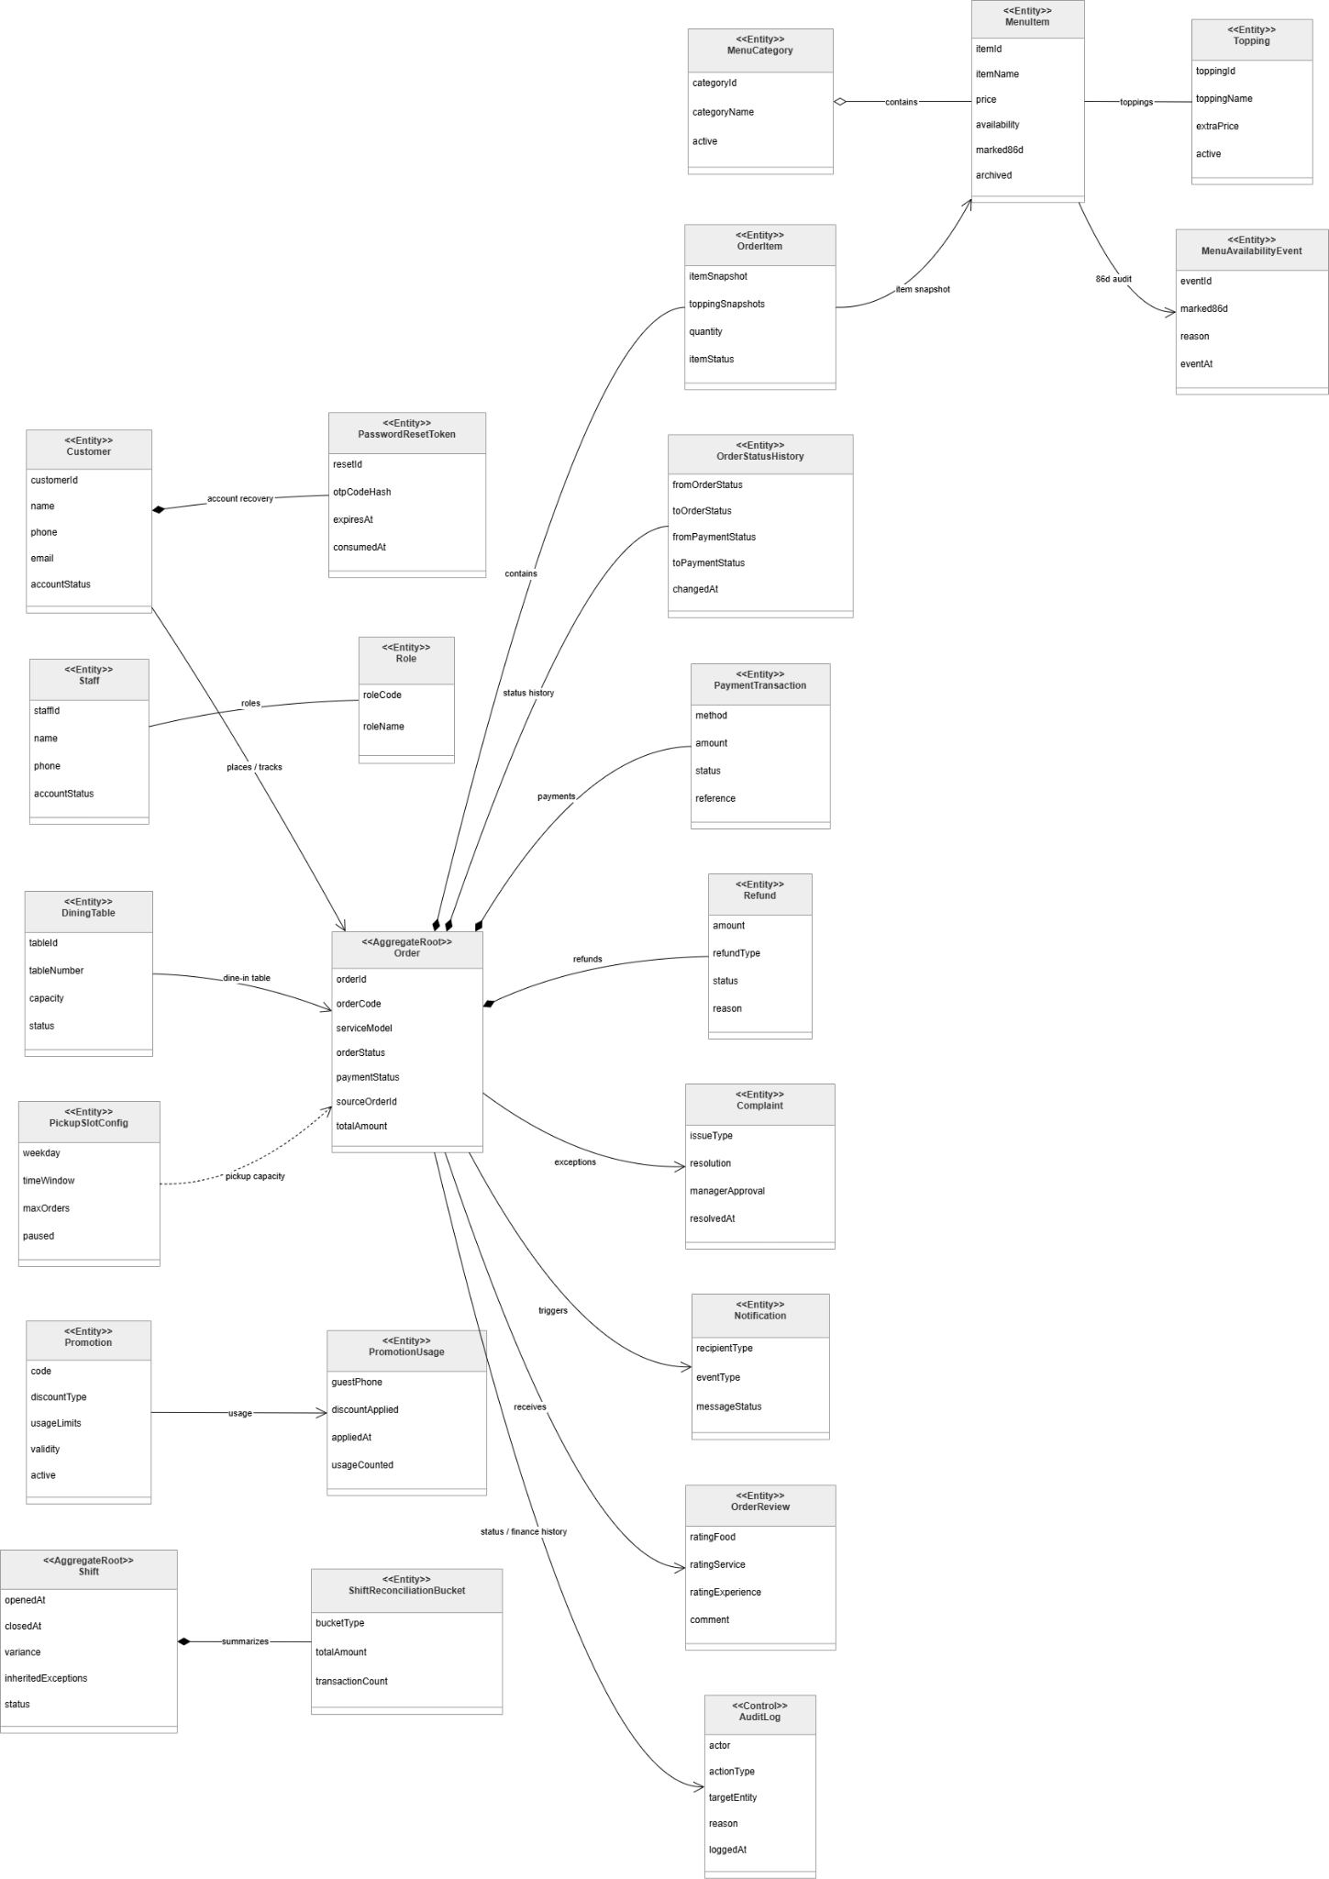

Figure 2 System class diagram
The class diagram presents the structural design of the WonTon POS system, illustrating the core entities and their relationships that support restaurant operations such as order processing, menu management, payment handling, and system monitoring. The system is designed using a domain-driven approach, with the Order entity acting as the central aggregate root that connects multiple components.
At the core of the system is the Order class, which represents a customer transaction. It stores essential information such as orderCode, serviceMode, orderStatus, paymentStatus, sourceOrderId, and totalAmount. Each order is associated with multiple OrderItem entities, which capture individual items within the order. The OrderItem class stores itemSnapshot, toppingSnapshots, quantity, and itemStatus, ensuring that product data remains consistent even if the menu changes later.
The menu structure is represented through MenuItem and MenuCategory. Each MenuItem contains attributes such as itemName, price, availability, and status flags like marked86d and archived. Menu items belong to a MenuCategory, allowing the system to organize products efficiently. Additionally, MenuItem is connected to Topping, which supports item customization, and MenuAvailabilityEvent, which tracks availability changes such as marking items as unavailable.
Customer and staff management are handled through separate classes. The Customer class stores user information such as name, phone, email, and accountStatus, and is linked to PasswordResetToken for account recovery functionality. The Staff class represents internal users and is associated with the Role class, which defines access permissions. This structure enables role-based access control and ensures that system actions are restricted based on user responsibilities.
The system also supports dine-in and pickup services. The DiningTable class represents physical tables in the restaurant, allowing orders to be assigned for dine-in scenarios. The PickupSlotConfig class defines time windows, capacity, and availability for pickup orders, enabling efficient scheduling and resource management.
Payment processing is managed through the PaymentTransaction class, which records details such as method, amount, status, and reference. Orders may also be associated with Refund entities, which track refund amount, type, status, and reason. This separation ensures clear financial tracking and supports error handling in transactions.
To support operational monitoring and customer interaction, the system includes several supporting classes. The Notification class manages system messages sent to users, while the OrderReview class allows customers to provide feedback on their experience. The Complaint class handles issues raised during order processing, including resolution and managerial approval.
In addition, the system includes Shift and ShiftReconciliationBucket classes to support staff shift management and financial reconciliation. The AuditLog class records system activities such as user actions, target entities, and timestamps, ensuring traceability and system accountability.
Overall, the class diagram demonstrates a well-structured and scalable design, with clear separation of concerns and strong relationships between entities. By organizing the system around the Order aggregate and supporting it with modular components, the design ensures efficient data management, flexibility, and maintainability for real-world restaurant operations.

3. ER diagram for system
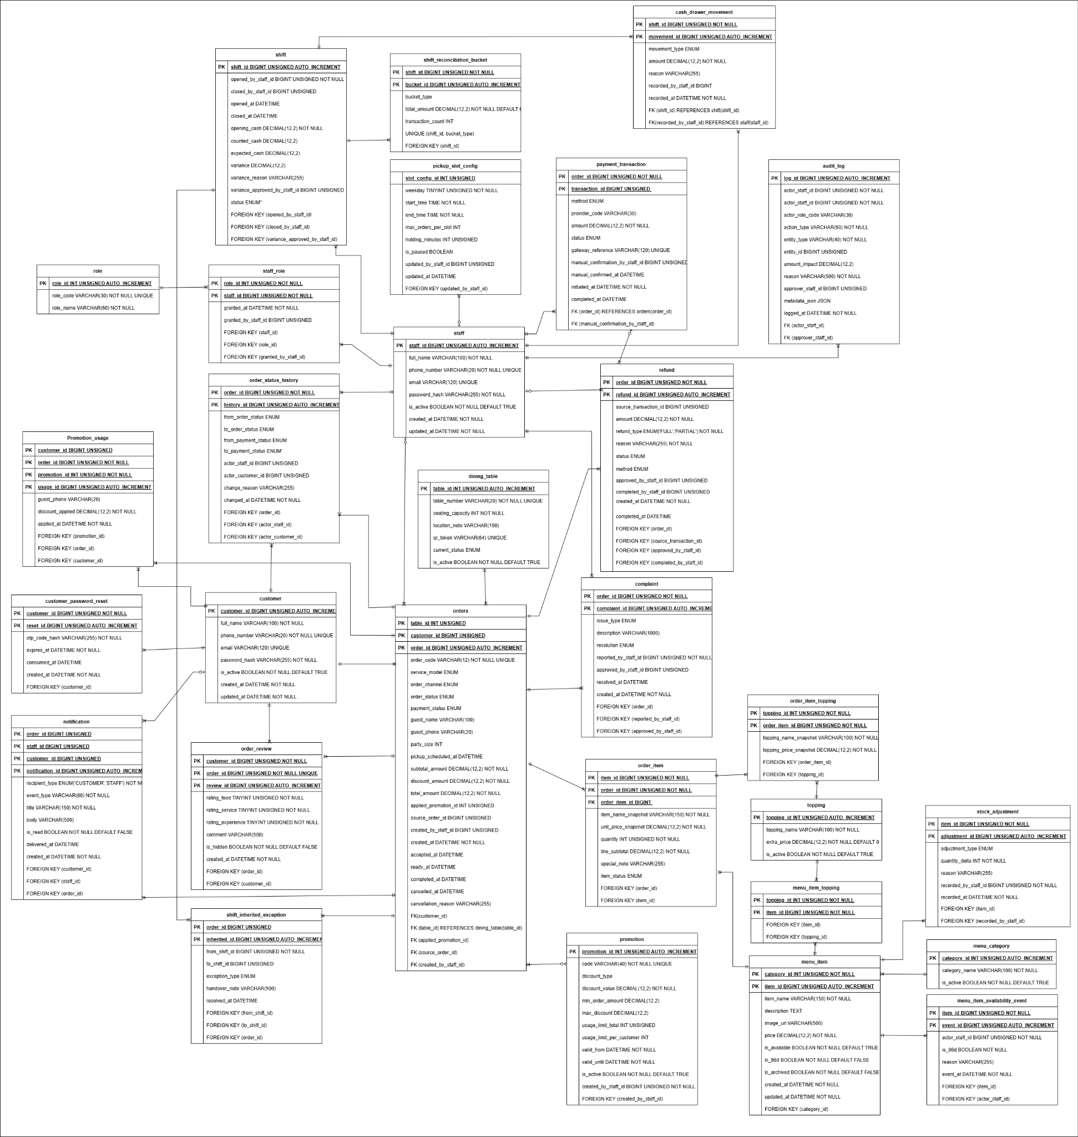
Fig 3. ERD diagram
The diagram represents the Entity-Relationship (ER) model of the WonTon POS system, illustrating the core entities and how they interact to support restaurant operations, including order processing, menu management, staff management, and payment handling.
Order and Transaction Management
At the center of the system is the orders table, which stores all transaction-related information such as order type, status, total amount, timestamps, and customer reference. Each order is associated with multiple order_items, representing individual dishes within the order. These order items are linked to the menu_items table, which contains detailed information about each food item such as name, price, and availability.
Orders are also connected to payments, which store payment method, transaction status, and payment details. This relationship ensures that each order is properly tracked and completed through a corresponding financial transaction.
Menu and Product Management
The menu_items entity plays a key role in representing the restaurant’s offerings. Each item belongs to a menu_category, allowing the system to organize dishes into logical groups for easier navigation and management. Additional customization options may be supported through related entities such as toppings or modifiers, enabling flexible order configurations. This structure allows the system to efficiently manage menu updates, pricing, and availability.
Customer and Account Management
Customer information is stored in the customers table, which includes details such as name, contact information, and account credentials. Customers can place multiple orders, establishing a one-to-many relationship between customers and orders.
In addition, customer-related data such as order history is maintained through this relationship, enabling features like reordering and tracking past transactions.
Staff and Role Management
The system includes a staff entity representing employees such as managers, FOH staff, and BOH staff. Each staff member is associated with a role, which defines their permissions and responsibilities within the system.
This structure supports role-based access control, ensuring that each user can only perform actions relevant to their job function, such as managing orders, updating dish status, or accessing reports.
Table and Service Management
For dine-in services, the dining_tables entity is used to manage table information within the restaurant. Orders can be associated with specific tables, enabling staff to assign and manage dine-in customers effectively. This relationship supports real-time table management and improves service coordination.
Notification and System Support
The system also includes supporting entities such as notifications, which store messages related to order updates and system alerts. These notifications are linked to orders and users, ensuring that customers and staff receive timely updates throughout the order lifecycle.
Overall, the ER diagram presents a well-structured database design that supports both operational processes and management functionalities. By clearly defining relationships between entities, the system ensures efficient data flow, accurate transaction handling, and scalability for future enhancements.

VI. Requirement Management
Requirement management is necessary because requirement errors are among the most expensive problems to correct after design or implementation has started. In the Wonton POS project, a single unclear rule can affect ordering, payment, kitchen preparation, customer communication, and manager reporting at the same time. Therefore, this section focuses on how the team controls approved business needs after elicitation, rather than simply describing how many documents were produced. Supporting documents such as the BRD, SRS, use-case tables, diagrams, and prototype are used only as verification evidence that the same controlled requirement baseline is being represented consistently.
The managed baseline for this thesis is the Wonton POS system for Dine-in, Takeaway, and scheduled Pickup operations across the Client WebApp and Admin WebApp. The baseline is defined by stakeholder needs, business rules, service boundaries, quality expectations, and the current release scope. The key principle is that every requirement must remain understandable, testable, prioritized, owned, and traceable from the original business problem to the final prototype and review evidence.
The Requirement Management Plan (RMP) defines five practical controls for this project: baseline control and use-case traceability, change management, prioritization and effort assessment, requirement risk management, and scope management. These controls answer the main management questions: what has been approved, what can still change, who reviews a change, which items are more important, what risks may block requirement satisfaction, and what belongs outside the current release.
1. Baseline Control, Status Tracking, and Traceability
Baseline control means that the team treats approved requirements as a managed set, not as loose notes. A requirement is controlled when its purpose, source, priority, owner, status, acceptance condition, and affected workflow are clear. Traceability is still important, but it supports requirement quality rather than dominating the thesis. In other words, the team traces requirements so that the business rule, user workflow, screen behavior, and validation criteria stay consistent.
The status lifecycle used in the project is: Proposed -> Analyzed -> Approved -> Deferred or Rejected -> Updated -> Verified. This lifecycle makes it clear whether a requirement is only an idea, already accepted into the baseline, waiting for later release, or already reflected in the relevant review evidence. No requirement is accepted into the managed baseline unless it has a clear source, priority, owner, acceptance condition, and release decision.
Baseline element | Purpose | Wonton POS application
Business need | Explains why the requirement exists. | Reduce handwritten order mistakes, improve FOH/BOH coordination, and give the owner clearer operational visibility.
Functional requirement | Defines what the system must do for users. | Support menu browsing, checkout, payment control, order tracking, KDS updates, table handling, and exception handling.
Quality requirement | Defines how well the system must perform. | Keep screens usable during peak service, protect customer/payment data, and provide clear status feedback.
Business rule | Defines operational constraints that cannot be ignored. | Takeaway and Pickup must be paid before kitchen preparation; order status and payment status are managed separately.
Requirement status | Shows the current management state of a requirement. | Use Proposed, Analyzed, Approved, Deferred, Rejected, Updated, or Verified to avoid unclear ownership and outdated wording.
Review evidence | Shows that the requirement is represented consistently. | Requirement text, workflow model, prototype screen, and acceptance check should describe the same behavior.

1.1 Requirements Traceability Matrix by Use Case
To make traceability reviewable, the project maintains a use-case-level Requirements Traceability Matrix (RTM). The matrix does not replace the BRD, SRS, detailed use-case specifications, or prototype evidence. Instead, it is a management view that shows whether each approved capability is connected to a business need, a controlled scope area, verification evidence, and an acceptance focus. This helps the team identify orphan requirements, missing validation evidence, and use cases that may require change review before the baseline is updated.
Use Case / Capability | Requirement Traced | Scope / Source Area | Verification Evidence | Acceptance Focus
UC-01: Place Online Order | Customer can browse menu, configure items, manage cart, and create an order request. | Client ordering; menu-to-cart flow | BRD/SRS functional requirement; Client menu, cart, and order prototype screens | Order captures service model, items, options, totals, and order state without bypassing payment or kitchen rules.
UC-02: Online Payment | Customer can complete supported online payment for orders that require prepayment. | Payment control; Takeaway/Pickup prepayment | Payment flow specification; retry, failure, callback, and refund-status prototype evidence | Payment result is recorded separately from order status; failed, duplicate, and late callbacks are handled consistently.
UC-03: Schedule Pickup Order | Customer can choose a pickup slot and submit a scheduled Pickup order after slot validation. | Pickup service model; capacity and time-slot control | Pickup workflow and checkout prototype evidence | Pickup slot and capacity are checked before acceptance; Pickup orders require payment before kitchen preparation.
UC-04: View Order History | Customer can view past orders and inspect order details after purchase. | Post-order customer visibility | Order history and order-detail prototype screens | Completed, cancelled, refunded, and pending-refund states are visible with enough detail for customer follow-up.
UC-05: Manage Menu | Manager can maintain menu items, categories, toppings, prices, and availability. | Admin menu governance | Admin menu management prototype; menu business rules | Menu changes do not corrupt historical orders; unavailable items are blocked from new orders when required.
UC-06: Manage Staff | Manager can create, update, deactivate, and assign roles to staff accounts. | Admin access control; staff governance | Staff management requirement evidence; role/permission prototype screens | Sensitive actions are restricted by role and inactive staff accounts cannot perform operational work.
UC-07: View Revenue Statistics | Manager can review revenue and operational statistics for business oversight. | Reporting and management visibility | Dashboard/reporting requirements and prototype screens | Revenue figures are derived from valid payment and reconciliation statuses, not only from created orders.
UC-08: Manage Tables | Manager can maintain dine-in tables and table layout/status information. | Dine-in table operations | Table management and floor-layout prototype evidence | Table status supports active dine-in service, including multiple open orders for the same party when applicable.
UC-09: Create In-Store Order | FOH or Cashier can create dine-in or takeaway orders at the counter. | Counter POS; walk-in order flow | Admin POS order-entry prototype and in-store order requirements | Service model is captured correctly; dine-in may pay later while takeaway cannot enter kitchen before payment.
UC-10: Process Payment | Cashier can process counter payments and settlement actions. | Cashier payment and reconciliation control | Counter payment prototype; receipt and settlement requirements | Payment status remains separate from order status; cash/QR results, receipts, refunds, and adjustments remain auditable.
UC-11: Track Order | Customer or guest can track order progress using account access or order code plus phone number. | Customer order visibility; guest lookup | Tracking and guest lookup prototype screens | Valid lookup shows the correct order; mismatched order code or phone number is rejected without leaking order data.
UC-12: Assign Order to Table | FOH can assign, adjust, or transfer orders between dine-in tables. | Dine-in coordination; table-order relationship | Table assignment requirement evidence and prototype screens | Table-order links remain consistent during transfer; active orders stay attached to the correct dining party.
UC-13: Receive Kitchen Orders | BOH can view eligible new orders and begin kitchen processing. | Kitchen intake; KDS queue | KDS intake prototype and kitchen workflow specification | Only eligible orders enter the kitchen queue; queue handling respects service model, payment readiness, and FIFO visibility.
UC-14: Update Dish Status | BOH can update item or order preparation progress until food is ready. | Kitchen execution; item/order status control | KDS status update prototype and dish-status rules | Grouped updates and item-level progress are reflected consistently; ready status is visible to FOH/customer flows.
UC-15: Rate Order | Customer can submit rating and feedback after an order is completed. | Customer feedback and post-service review | Rating page prototype and feedback requirement evidence | Only eligible completed orders can be rated; feedback is linked to the correct order record.
UC-16: Receive Order Notifications | Customer can receive notifications when order status changes. | Customer communication; notification history | Notification center prototype and status-change rules | Relevant status changes generate notifications without changing the source order state incorrectly.
UC-17: Reorder Past Order | Customer can reuse a completed order as the basis for a new order. | Customer lifecycle; repeat purchase | Reorder prototype and menu-drift rules | Price, topping, deleted item, archived item, and 86'd item differences are surfaced before checkout.
UC-18: Manage Promotions | Manager can create, edit, deactivate, and review promotion usage. | Promotion governance; pricing control | Promotion management and usage-audit prototype screens | Validity, usage limit, stacking, cancellation, and failed-application rules are controlled and auditable.
UC-19: View Operational Dashboard | Manager can monitor active orders, revenue snapshot, alerts, and operational indicators. | Manager oversight; daily operations monitoring | Operational dashboard prototype and reporting requirements | Dashboard data reflects current operational state and highlights exceptions that require action.
UC-20: Manage Active Orders | FOH or Manager can monitor, confirm, cancel, or intervene in active orders. | Active operation control; exception prevention | Active orders prototype and operational workflow evidence | Changes respect kitchen timing, payment state, service model, and manager approval for sensitive actions.
UC-21: Close Shift and Reconcile End-of-day | Manager or Cashier can close a shift, reconcile payments, and record differences. | Financial control; shift close and reconciliation | Shift-close and reconciliation prototype screens | Transactions are attributed by event timestamp; exceptions and inherited issues are carried into handover when unresolved.
UC-22: Mark Menu Item as 86'd | Manager or authorized staff can mark menu items temporarily unavailable. | Inventory-lite availability control; menu protection | 86'd availability prototype and audit rules | The item is blocked from new orders; audit trail captures who changed it, when, and why, without assuming full inventory automation.
UC-23: Serve and Confirm Handoff | FOH can serve ready items and confirm correct handoff to the customer or table. | Service completion; dine-in/takeaway handoff | Serve/handoff prototype and ready-to-completed workflow rules | Correct order, table, and customer are confirmed before completion; wrong-handoff correction remains traceable.
UC-24: Handle Complaint and Operational Exception | Staff and Manager can handle complaints, remakes, refunds, wrong handoff, and operational exceptions. | Exception handling; manager correction | Complaint/exception prototype and operational policy evidence | Response, owner, decision, and financial outcome are recorded, including refund, comp, write-off, or forfeited cases where applicable.
UC-25: Manage Customer Account and Authentication | Customer can register, log in, recover password, update profile, change password, and log out. | Customer access and identity control | Authentication, profile, and recovery prototype screens | Account actions validate identity and input correctly while guest checkout remains available for eligible flows.
UC-26: Complete Checkout and Apply Promotion | Customer can finalize checkout, choose service model, enter required details, and apply eligible promotions. | Checkout completion; pricing and service-model selection | Checkout and promotion-application prototype evidence | Service model, customer information, totals, promotion result, and payment requirement are validated before order submission.

The RTM is updated whenever a use case is approved, deferred, changed, or verified. If a use case cannot be traced to a business need, controlled scope area, verification evidence, and acceptance focus, it must be reviewed before remaining in the managed baseline.
2. Change Management
Change management is used to prevent useful feedback from becoming uncontrolled scope creep. The project applies a lightweight Change Control Board approach: new or modified requirements are proposed, analyzed, approved or deferred, and then communicated to the team. The change review group includes the BA lead, the owner of the affected requirement evidence, and the project sponsor or designated scope reviewer for scope-sensitive decisions. Decisions are based on business value, scope fit, operational impact, risk, dependency, and available revision effort rather than feature attractiveness alone. The review also considers whether the change affects payment rules, kitchen workflows, reconciliation, prototype evidence, or acceptance conditions.
Step | Control rule | Wonton POS example
1. Propose | Record the requester, reason, affected workflow, and expected value. | A stakeholder asks to clarify guest lookup, bank-transfer confirmation, or pickup no-show handling.
2. Analyze | Review impact on scope, priority, risk, effort, related workflows, and affected evidence owner. | The BA checks whether the change affects payment status, order status, kitchen preparation, reconciliation, promotion, or audit behavior.
3. Decide | Approve, reject, or defer the request through the lightweight review group. | Clarifications inside the current restaurant operations may be accepted; Delivery, loyalty points, procurement, and native apps are deferred.
4. Apply | Update the controlled requirement and the affected evidence together. | A payment-rule change must be reflected in the requirement wording, workflow description, prototype behavior, and validation criteria.
5. Communicate | Inform team members so everyone continues from the same baseline. | Review meetings and document checkpoints are used to prevent parallel versions of the same requirement.

3. Prioritization, Effort Assessment, and Scalability
Prioritization helps the team decide sequencing and review depth. It is not used to silently remove approved requirements. The project applies a simplified MoSCoW and value-risk-effort view. Requirements are considered against business benefit, penalty of not implementing them, risk, dependency, technical difficulty, customer priority, time sensitivity, stability, and policy compliance. Effort assessment is also necessary because one requirement can require analysis, writing, modelling, prototype adjustment, peer review, and revision.
Priority / effort class | Decision criteria | Wonton POS examples
Must have | Without it, the core restaurant workflow fails. | Ordering, service model selection, Takeaway/Pickup prepayment, kitchen status, order tracking, staff access control, refund status.
Should have | Important for realistic operations and final-project completeness. | Reorder, promotion governance, active order monitoring, shift close, 86'd item handling, handoff confirmation, complaint handling.
Could have | Useful for documentation quality or edge-case maturity when time allows. | Additional prototype states, notification-history refinements, report filters, and supporting explanation details.
Won't have now | Outside the baseline or too large for the project timeline. | Delivery integration, loyalty points, supplier procurement, payroll, full accounting ledger, and native mobile application.

Scalability in requirement management means the requirement set can grow without becoming uncontrolled. The project handles this by separating current-release requirements from future-release candidates, keeping ownership clear, and avoiding the trap of treating every useful idea as immediately necessary.
4. Risk Management
Risk management in this section focuses on requirement risks, not only general project risks. The project classifies requirement-related risks into process, product, technology, elicitation, analysis, specification, and management risks. For Wonton POS, the most important requirement risks are expectation gaps, ambiguous business rules, missing non-functional requirements, unprioritized features, scope creep, and inconsistent interpretation of payment or kitchen workflows.
Requirement Risk Categories
Risk category | Typical cause | Control applied in Wonton POS
Process-related mistakes | Optimistic schedules, fuzzy front end, insufficient planning, or planning to catch up later. | Use a clear baseline, review checkpoints, and done criteria for each major requirement-management block.
Product-related mistakes | Feature creep, requirement gold-plating, or negotiation pressure from different stakeholders. | Use Vision and Scope, MoSCoW priority, and future-release boundaries to keep the product focused.
Technology-related mistakes | Switching tools late or assuming a new tool will solve requirement uncertainty. | Treat prototype tools as evidence only; do not introduce new tooling unless it supports the final deliverable.
Elicitation risks | Expectation gap, unstated requirements, customer distrust, or undiscovered real needs. | Use interviews, observation, questionnaire, meetings, prototype walkthroughs, and what-if questions.
Analysis risks | Requirements are not prioritized or technically difficult features are underestimated. | Check priority, dependency, risk, and effort before accepting a requirement into the baseline.
Specification risks | Ambiguous terminology, unnecessary design constraints, or incomplete requirement statements. | Use clear glossary terms, peer review, measurable wording, and avoid embedding implementation decisions as business requirements.
Management risks | Unable to react to changes, expanding project scope, or unimplemented requirements. | Use change review, impact analysis, version control, ownership, and traceability checks.

Requirement Risk Log
Risk ID | Risk description | Probability / impact | Owner / response | Mitigation / monitoring
RR-01 | Scope expands into Delivery, loyalty, procurement, native apps, or full accounting. | Medium / High | BA lead / avoid and defer | Keep those items outside the current release and record them only as future-release candidates.
RR-02 | Different sections or screens describe inconsistent behavior. | Medium / High | BA lead + evidence owner / reduce | Review requirement wording, workflows, prototype behavior, and acceptance criteria together.
RR-03 | Takeaway or Pickup enters kitchen preparation before valid payment is confirmed. | Medium / High | BA lead + payment workflow owner / avoid | Keep payment-before-kitchen explicit and separate order_status from payment_status.
RR-04 | Operational exceptions such as no-show pickup, refund pending, wrong handoff, 86'd item, complaint, or outage recovery are missed. | Medium / High | Operations workflow owner / reduce | Maintain named alternate and exception flows with manager approval and audit reasons for sensitive corrections.
RR-05 | Prototype screens drift away from the approved requirement baseline. | Medium / Medium | Prototype owner / reduce | Review Client/Admin screens against service models, payment states, account paths, staff operations, and exception scenarios.
RR-06 | Staff adoption is weak because FOH, BOH, or cashier screens are unclear during peak service. | Medium / Medium | UX/prototype owner / reduce | Use role-based views, high-contrast UI, large touch targets, clear status labels, and stakeholder walkthrough feedback.
RR-07 | Guest lookup, staff accounts, or payment-related data are exposed to unauthorized users. | Low / High | Security/RBAC owner / reduce | Apply access control, guest lookup by Order Code + Phone Number, rate limiting, audit logs, and data-retention rules.
RR-08 | Non-functional requirements are neglected because functional workflows receive more attention. | Medium / Medium | Quality requirement owner / reduce | Ask stakeholders to define acceptance criteria for performance, usability, security, availability, and accessibility.

Risk mitigation is documented using probability, condition, consequence, impact, owner, and response. Responses may reduce risk probability, reduce business impact, transfer review responsibility to the right role, avoid the risk by keeping an item out of scope, or accept low-impact risks with monitoring. The team also checks risky work early, invites review from knowledgeable stakeholders, avoids unfamiliar tools late in the project, and keeps a backup trail for key requirement decisions.
5. Scope Management
Scope management protects Wonton POS from becoming a general restaurant platform. The current project is a focused POS and operations-support system for a wonton noodle shop, not a production deployment commitment. The scope includes product functionality, available team resources, and the timeline for producing a reviewable thesis and requirement package. When the team asks whether a feature is required or worth the effort, the answer must come from the approved Vision and Scope, stakeholder value, risk, dependency, and effort.
Scope category | Included in the Wonton POS baseline | Excluded / future-release boundary
Service models | Dine-in, Takeaway, and scheduled Pickup, including guest checkout and registered customer flows. | Delivery and direct third-party delivery-platform integration.
Customer functions | Menu browsing, cart, checkout, promotion application, payment-status feedback, tracking, notifications, order history, reorder, account management, and rating. | Membership tiers, loyalty points, customer wallet, and native mobile apps.
Admin operations | Menu/category/topping management, staff access control, table management, active orders, KDS updates, 86'd availability, handoff, complaints, pickup exceptions, and outage recovery. | Supplier procurement, full recipe-level inventory automation, payroll, and full accounting ledger.
Financial controls | Counter payment, payment gateway QR, manual bank-transfer confirmation, refund states, write-off/comp/forfeited handling, receipt support, shift close, and reconciliation. | Real banking settlement integration beyond documented gateway/manual-confirmation assumptions.
Project deliverables | Thesis narrative, controlled requirement evidence, specifications, diagrams, requirement management, and prototype evidence. | Production coding, deployment, and operational go-live commitments unless explicitly assigned later.

To keep this boundary enforceable, every functional requirement must map back to an approved business need, workflow, quality expectation, or operational rule. A feature that cannot be traced to the customer journey, Admin operations, kitchen workflow, payment/reconciliation control, or approved exception handling is not added to the current baseline. This keeps the requirement package realistic while still demonstrating a complete understanding of the target restaurant system.

VII. Prototype
This section presents the interactive prototype developed for the Wonton POS system to validate the documented use cases, business rules, and non-functional requirements (e.g., NFR-04 for cross-device responsiveness, NFR-07 for WCAG AA color contrast). The prototype was designed in Figma as 86 high-fidelity screens (35 Client WebApp, 51 Admin WebApp), serving as the definitive visual artifact for stakeholder validation and requirement verification.

2.7.1. User Interface
The visual design system establishes a cohesive identity across all application modules through consistent typography, a structured color palette, and a shared component library that ensures uniformity across the 86-screen prototype.

Client WebApp Interface
The Client WebApp consists of 35 screens built upon a mobile-first responsive grid. Key interfaces include the Authentication module (supporting both registration and Guest Checkout), Menu Browse, and Item Customization. Checkout and payment flows are strictly decoupled into three service environments (Dine-in, Takeaway, Pickup) spanning 9 state screens to govern edge cases. Additional interfaces cover Order Tracking, Rating, and Account Profile management.

Admin WebApp Interface
The Admin WebApp features 51 screens optimized for high data throughput. Key operational modules include the Dashboard, Order Management, and a color-coded Table Management floor plan (teal for available, blue for occupied, amber for reserved). Back-of-House operations are centralized via the Kitchen Display System (KDS) displaying FIFO queues. Management interfaces govern Staff, Menu, Vouchers, and Revenue Statistics. Exception handling is supported through dedicated screens for Shift Reconciliation, Active Orders, Complaints, and out-of-stock (86'd) management.

2.7.2. User Experience

Customer Journey
The customer path emphasizes rapid conversion and transparency. Navigation adapts dynamically based on authentication state. Service-specific logic enforces prepayments for Takeaway and Pickup, while Dine-in permits post-meal settlement. Edge-case UX is explicitly handled, notably through proactive Reorder alerts when menu drift (price/ingredient changes) occurs, and clear recovery paths for payment failures.

Staff Workflow
Front-of-House workflows prioritize rapid input through status-filtered order views and intuitive table assignments. Back-of-House workflows rely on the KDS to manage preparation states (Cooking, Ready), fulfilling NFR-06 by synchronizing real-time updates directly to the customer's tracking screen. Management workflows emphasize structured resolution for exceptions (complaints, no-shows) over ad-hoc decision processes, ensuring consistent operational standards.

VIII. Revision of Project
Developing the Wonton POS system has yielded profound practical insights, evolving from an initial requirements study into a viable and comprehensive digital transformation strategy. Through the rigorous phases of stakeholder analysis, data elicitation, and system documentation, the project team has synthesized core professional competencies that will serve as a foundational bedrock for complex enterprise-level business analysis endeavors in the future. The project successfully bridged the gap between abstract academic theories and the harsh realities of commercial F&B operations.
The pivotal success of the project's foundational phase can be directly attributed to the agile application and triangulation of diverse requirement elicitation techniques. The team quickly identified that relying solely on formal, boardroom-style interviews with the CEO was inadequate for capturing the nuanced realities of daily operations. Consequently, the team conducted direct, unobtrusive observations at the restaurant during peak dining hours. This ethnographic approach allowed the team to accurately pinpoint critical, yet previously unarticulated, operational bottlenecks. Witnessing first-hand the profound inefficiencies of serving staff repeatedly running to the kitchen for status updates, or observing critical preparation errors stemming from illegible handwritten order tickets, provided the empirical evidence required to design digital workflows that genuinely resolve real-world pain points.
Furthermore, the strategic deployment of visual modeling tools during the analysis phase demonstrated immense utility, though it required iterative refinement based on stakeholder feedback. Initially, the team utilized complex swimlane diagrams to delineate systemic responsibilities. However, a crucial lesson learned was that for effective communication with non-technical stakeholders, simplifying the presentation into flattened process flowcharts was far more effective. By utilizing specific, universally recognized geometric symbols—such as distinct ovals for precise start and end points, and clear diamonds for decision nodes—the team fostered a much higher degree of absolute logical consensus. Concurrently, the high-fidelity Figma prototype acted as the ultimate communicative bridge. It enabled the stakeholders to comprehensively visualize the user experience flow, drastically mitigating the risk of requirement misunderstandings before the resource-intensive software coding phase commenced.
From the perspective of business architecture design, the most transformative insight derived from the project was the strategic decoupling of two entirely independent data state axes: the order_status (engineered specifically to govern the kitchen's preparation workflow) and the payment_status (designed to securely manage the cashier's financial auditing). This sophisticated architectural decision, when paired with an agile account authorization framework that supports multi-role employees rather than restricting users to rigid, singular job titles, endowed the Wonton POS system with unparalleled operational elasticity. This specific innovation proved to be the definitive key to resolving the chronic challenges associated with high staff turnover and shifting daily responsibilities, which are deeply entrenched characteristics of the Food and Beverage industry.
As the project transitions toward future iterative development cycles, the team has outlined a strategic roadmap for continuous improvement. The immediate next step involves conducting rigorous Usability Testing sessions directly on-site with the actual cashiers and kitchen staff utilizing the current Prototype. The primary objective is to empirically evaluate whether the designed touch targets and screen transition flows are genuinely ergonomic within a high-velocity, physically demanding culinary environment. Furthermore, based on early UI/UX evaluations, future design iterations will consciously pivot away from heavily automated, AI-centric notification systems that can overwhelm users. Instead, the interface will champion a more manual, user-controlled aesthetic—resembling a transparent, intuitive community feed—to ensure staff feel fully in command of the system and trust the operational flow. Once the baseline MVP operates stably, future phases will strategically explore the integration of advanced functional modules, such as secure API handshakes with third-party delivery logistics partners like GrabFood and ShopeeFood, in-depth inventory management subsystems to prevent ingredient shrinkage, and gamified customer loyalty ecosystems aimed at maximizing sustainable revenue growth.

REFERENCES
B-Company (2025) Technology Adoption in Vietnam's F&B SMEs: Current Gaps, Challenges and Strategic Solutions. Available at: https://b-company.jp/technology-adoption-in-vietnams-fb-smes-current-gaps-challenges-and-strategic-solutions/
IJIRT (2024) Enhancing Restaurant Operations through Modern POS Systems. Available at: https://ijirt.org/publishedpaper/IJIRT174275_PAPER.pdf
IJCRT (2020) Conceptual Study of Point of Sale System. Available at: https://ijcrt.org/papers/IJCRT2006464.pdf
GoSnappy (2025) Chinese Restaurant POS System Guide. Available at: https://gosnappy.io/blog/chinese-restaurant-pos-system/
NRSPlus (2024) POS Data Analysis for Business Growth. Available at: https://nrsplus.com/blog/pos-data-analysis/
Shopify (2025) Point of Sale Data Analysis Examples. Available at: https://www.shopify.com/blog/point-of-sale-data-analysis
Mona Media (2025) Restaurant Management System and AI Applications. Available at: https://mona.media/restaurant-management-system/
GoFrugal (2025) Essential Restaurant Management Tools. Available at: https://www.gofrugal.com/blog/essential-restaurant-management-tools/
AaltoDoc (2020) Intention to Adopt POS Systems in Vietnam Restaurants. Available at: https://aaltodoc.aalto.fi/items/37358780-aab9-4d25-951d-97d1e4ff0ab5
LimeTray (2025) Restaurant POS System Functional Requirements Checklist. Available at: https://limetray.com/blog/restaurant-pos-system-functional-requirements-checklist/
Pegotec (2025) Business Analysis for Software Projects. Available at: https://pegotec.net/unveiling-the-secrets-to-successful-business-analysis-for-software-projects/
GetSoftwareService (2024) Top 10 Business Analysis Tools and Techniques for Effective Project Management. Available at: https://getsoftwareservice.com/top-10-business-analysis-tools-and-techniques-for-effective-project-management/
IBM (2025) What is requirements management? Available at: https://www.ibm.com/topics/what-is-requirements-management
Techcanvass (n.d.) What Are Requirement Prioritization Techniques? Available at: https://techcanvass.com/blogs/requirement-prioritization-techniques.aspx
Business Analyst Learnings (2017) Requirements Risk Management: What's In It For Business Analysts? Available at: https://www.businessanalystlearnings.com/blog/2017/7/4/requirements-risk-management
ModernAnalyst (n.d.) Requirements Risk Management. Available at: https://www.modernanalyst.com/Resources/Articles/tabid/115/ID/212/Requirements-Risk-Management.aspx
Kassab, M. and Destefanis, G. (2015) Requirements Effort Estimation: State of The Practice. Available at: https://www.researchgate.net/publication/280557176_Requirements_Effort_Estimation_State_of_The_Practice
Rak, K., Car, Z. and Lovrek, I. (2019) Effort estimation model for software development projects based on use case reuse. Journal of Software: Evolution and Process, 31(2), e2119. Available at: https://doi.org/10.1002/smr.2119

